**Coding Challenge-4**

Date: **10/12/2024**

Name: **Harish E.R**

**Q) Copy activity from datalake to datalake in azure datafactory**

This explains how to copy a CSV file from one container (inputdata) to another (outputdata) within the same Azure Storage Account (sahithyadb) using Azure Data Factory. The process involves converting the CSV file into JSON format during the transfer.

**Copying from datalakegen1hexaware to datalakegen2hexaware:**

* **datalakegen1hexaware:**

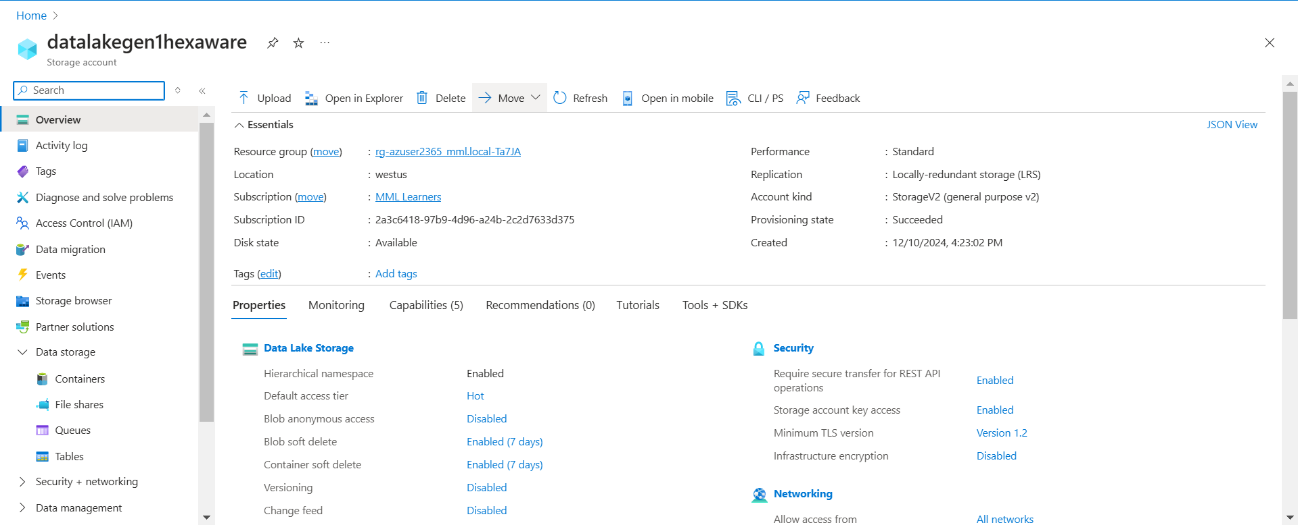

* **datalakegen2hexaware:**

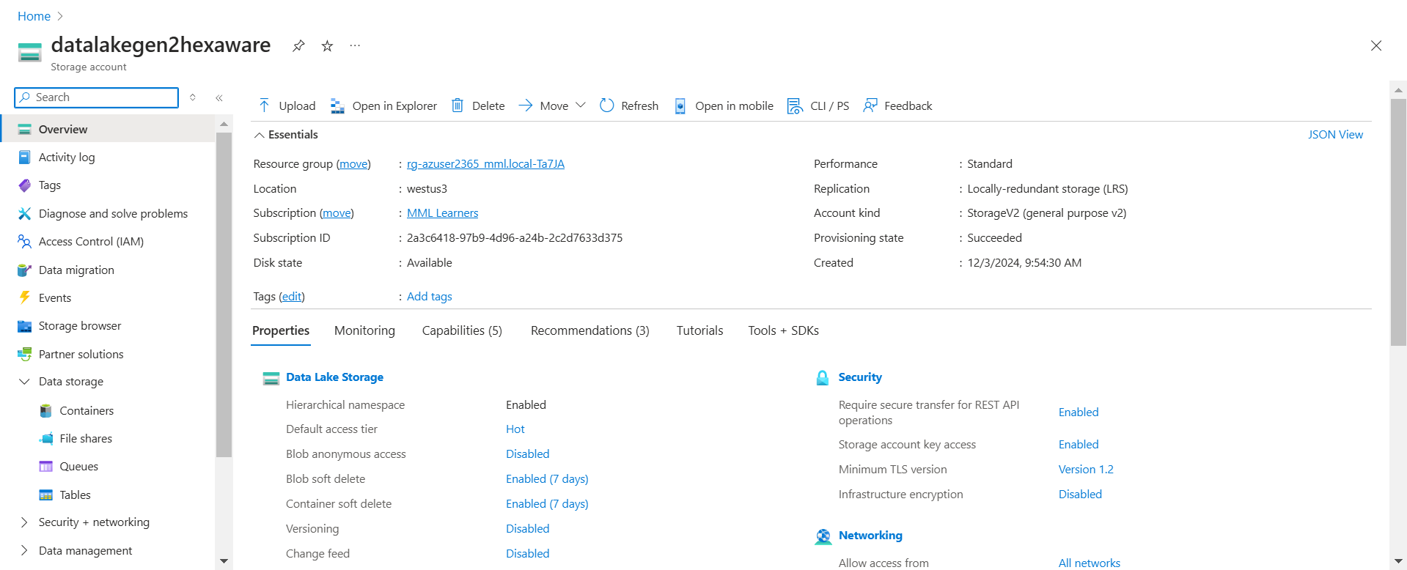

**Step 1) Make Datafactory account:**

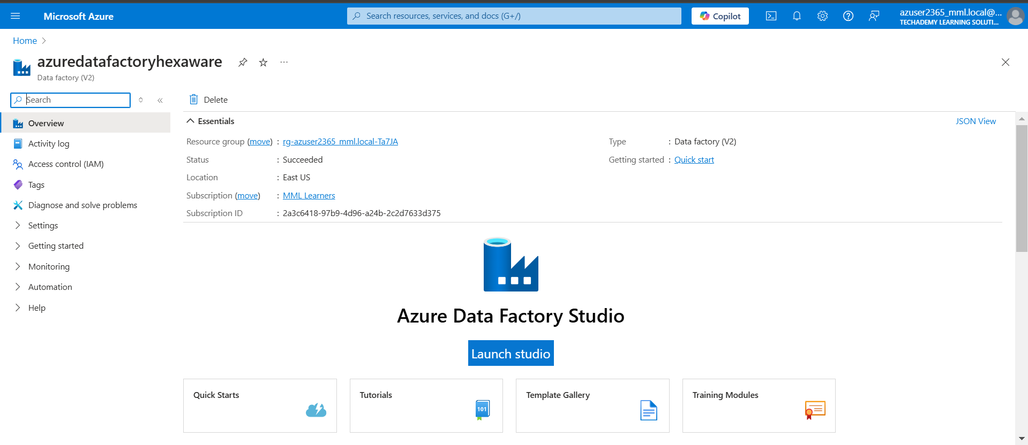

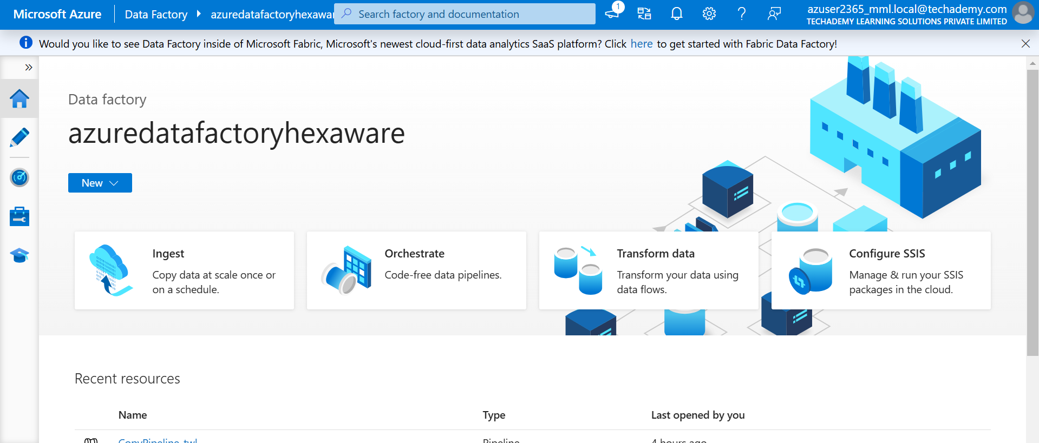

**Step 2: Check the properties in the Copy Data Tool:**

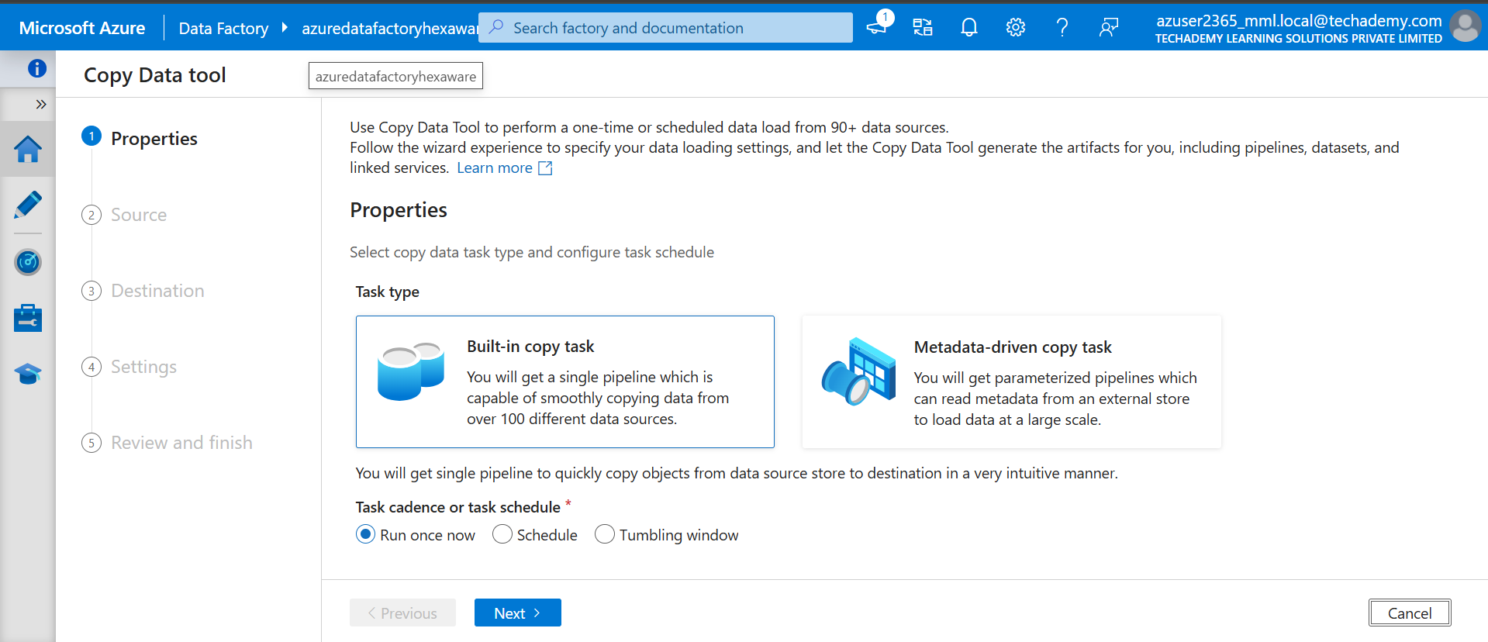

**Step 3: Check and click the Source for copying:**

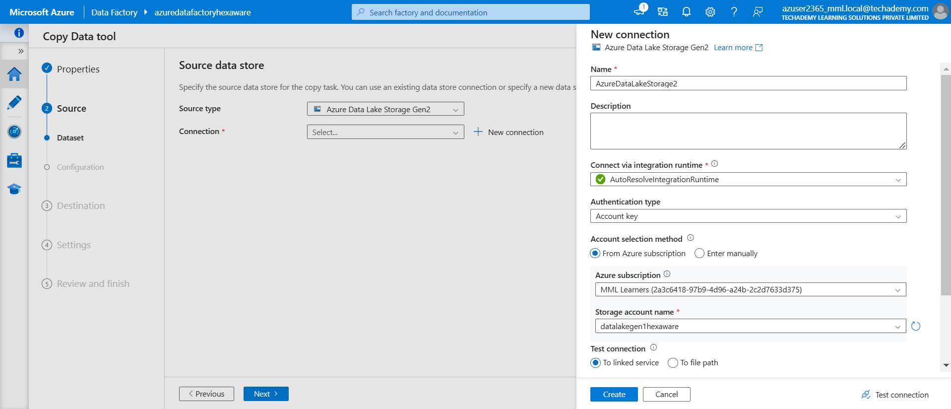

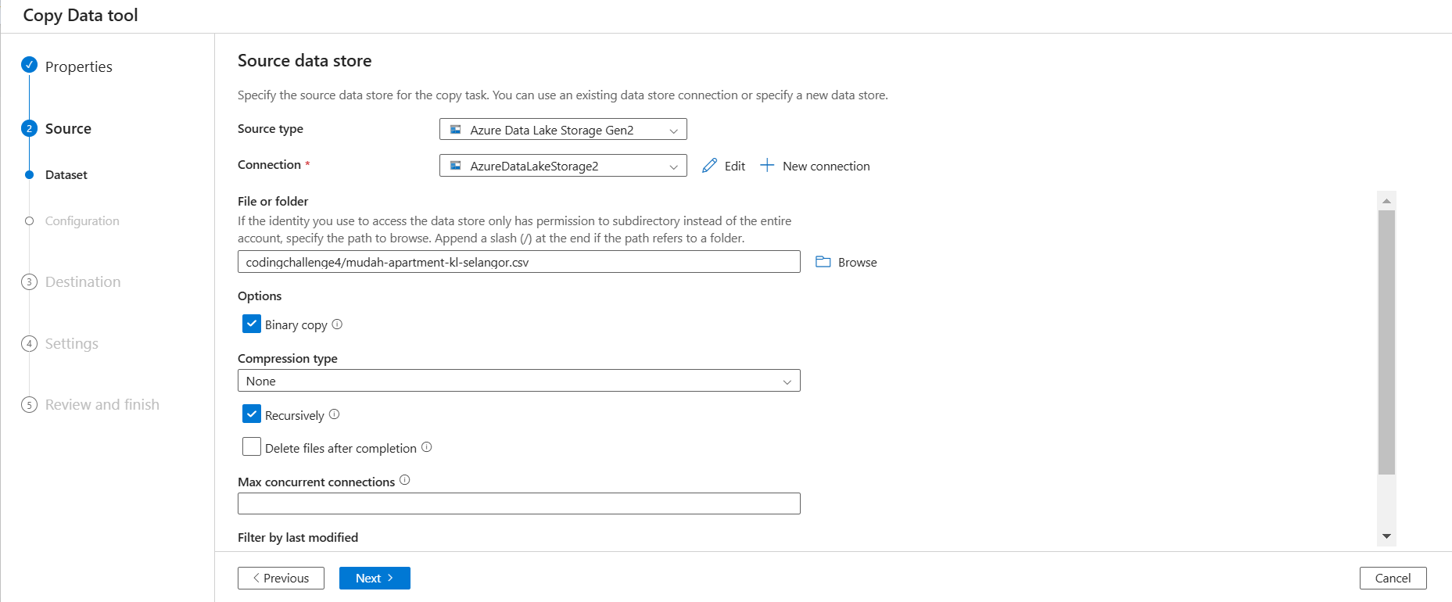

**Step 4: Setup Destination path for copying:**

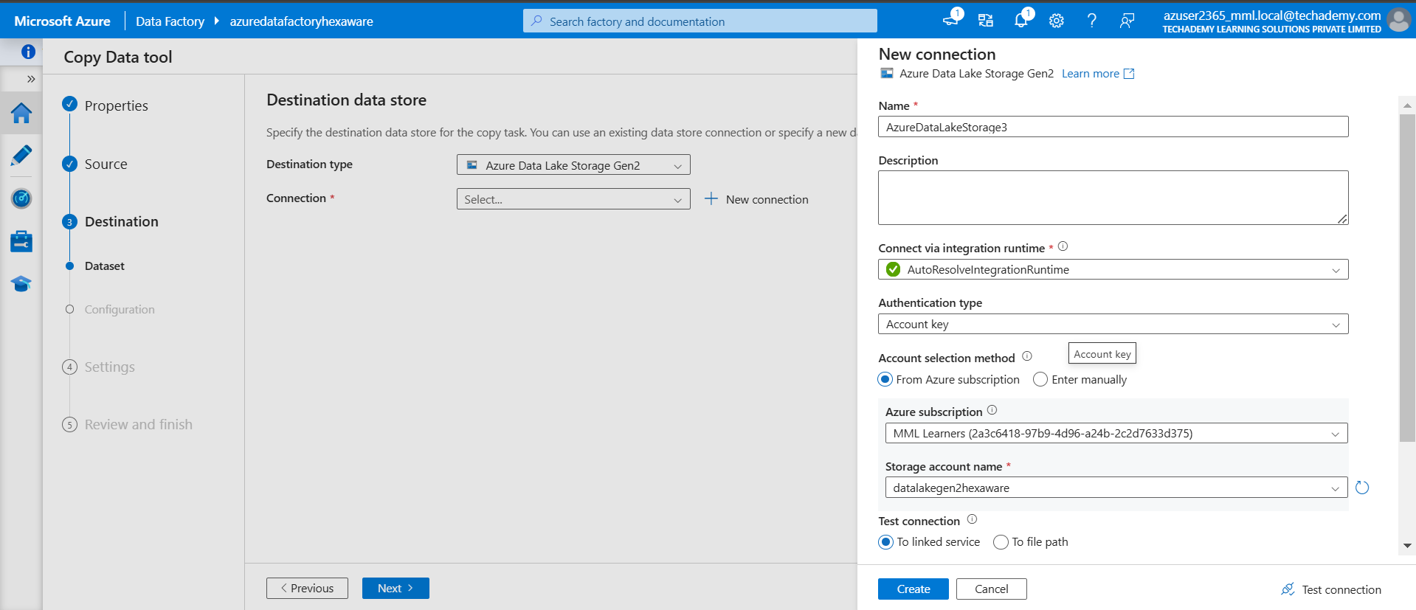

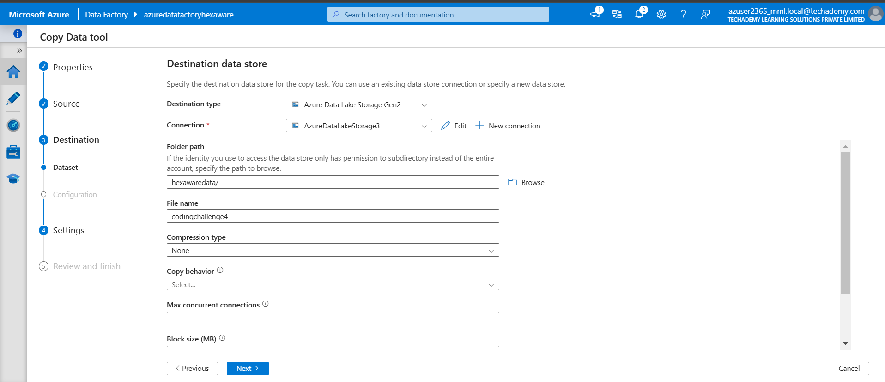

**Step 5: Setup settings:**

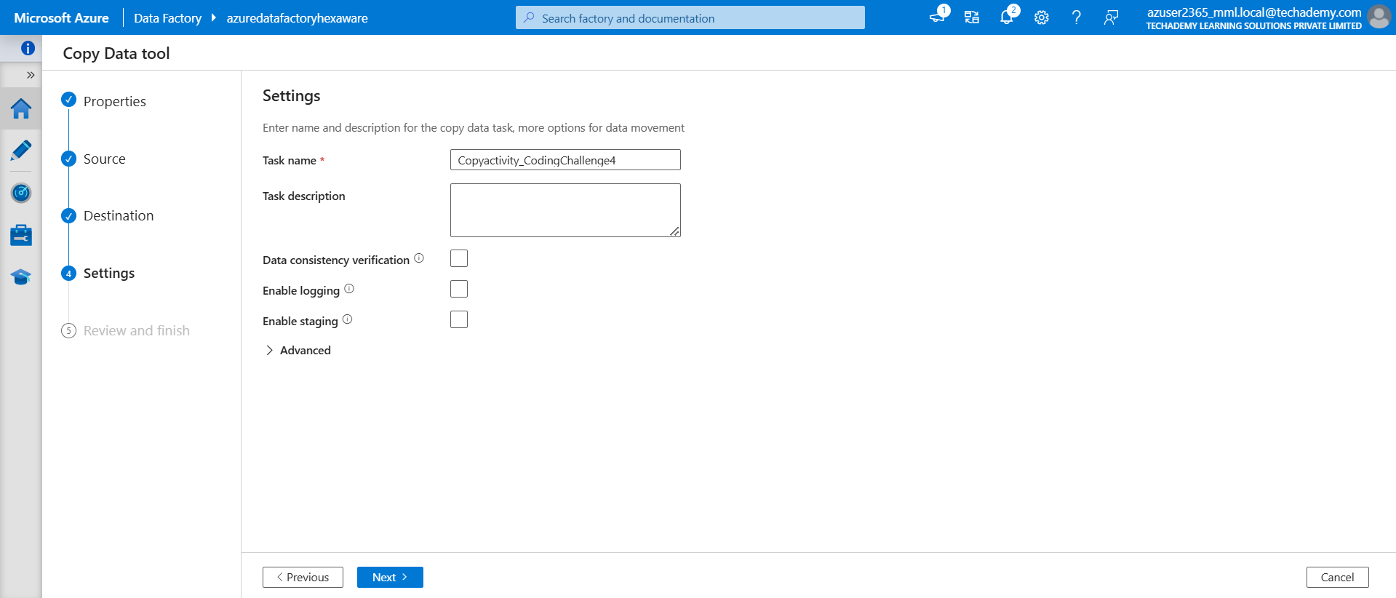

**Step 6: Review and click Deploy:**

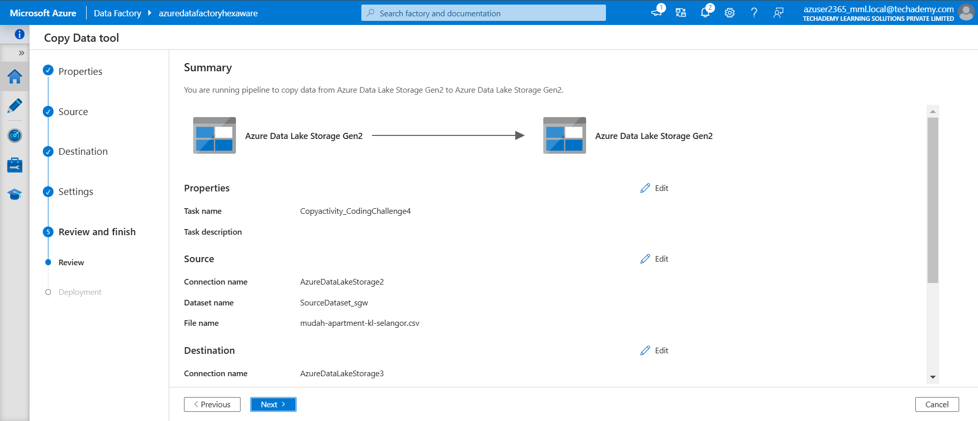

**Step 7: Run the pipeline:**

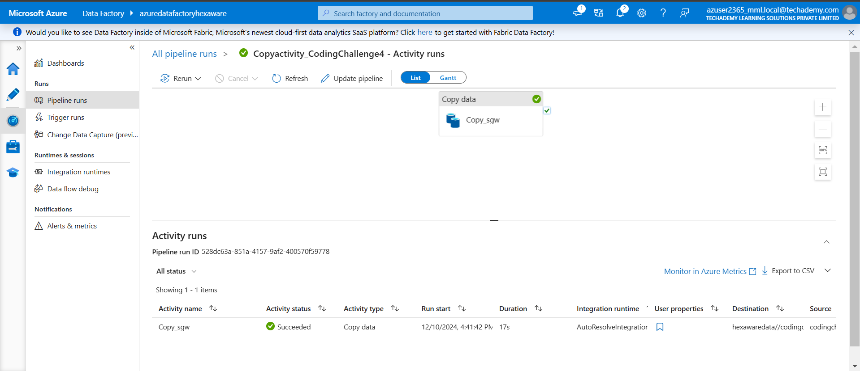

* **datalakegen2hexaware before copying:**

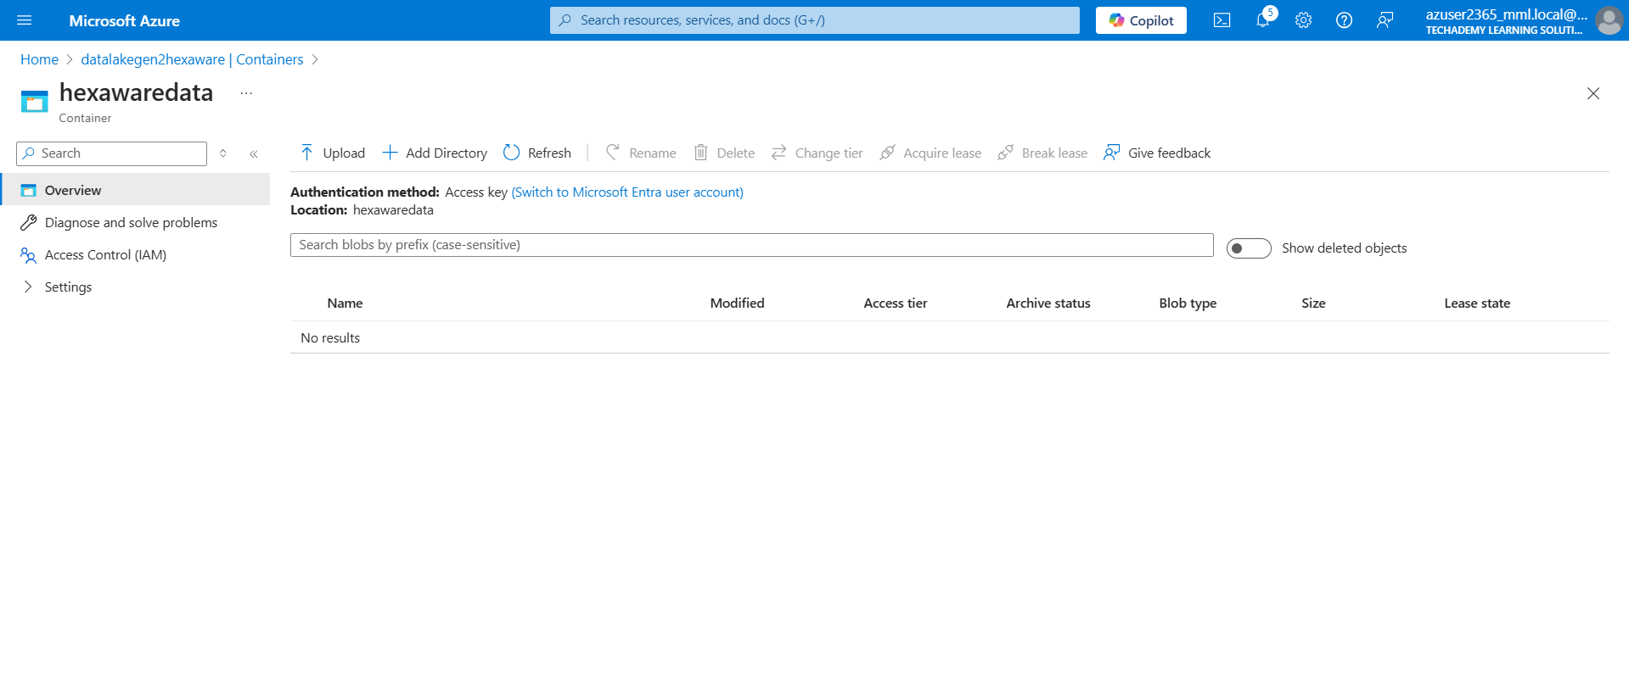

* **datalakegen2hexaware after copying:**

